

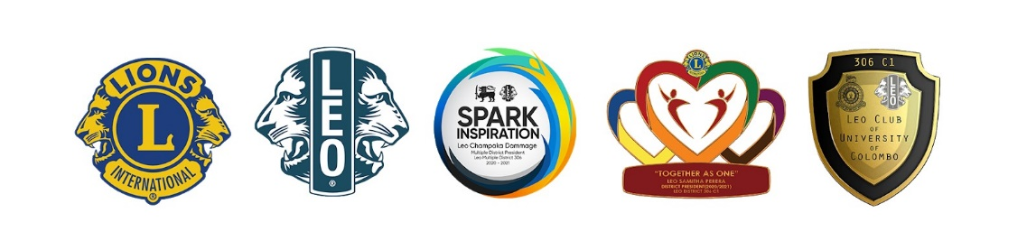**Leo Club of University of Colombo**

**District 306 C1**

**Sri Lanka**

By: Leo Chanaka Wickramasinghe

Leo Medani Gunathilaka

Leo Anuradha Wickramasinghe